# Design Overview for Binnies

Name: Han Nguyen

Student ID: 104101431

# Summary of Program

Describe what you want the program to do… one or two paragraphs.

My program will be a game that is inspired from Food Hunter. I will create a trash bin for user to drag and collect garbage. There are 3 different modes: red bin, yellow bin and green bin. Players have to collect the right type of trash to earn points, otherwise their points will be deducted.

Include a sketch of sample output to illustrate your idea.

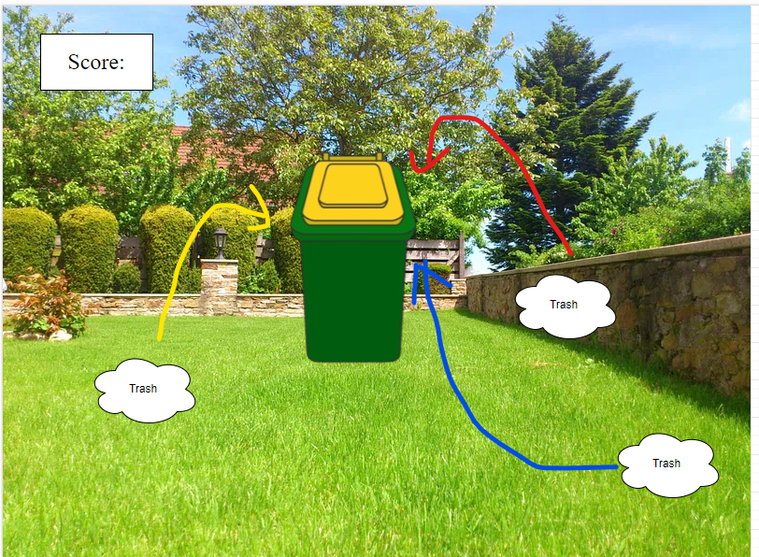

# Required Data Types

Describe each of the records and enumerations you will create using the following table (one per record).

Table : Trash Bin details

|  |  |  |
| --- | --- | --- |
| Field Name | Type | Notes |
| score | integer | Scores players earn |
| Image | Image .png or .jpeg | images of bins with different colour lids |
| Yay.wav  Nahhh.wav | Sound .wav, .mp3 | Sounds of accepting or denying types of trash |
| Position of bin (x, y) | float | Coordinate x and y of bin |

Table : Zorder details

|  |  |
| --- | --- |
| Value | Notes |
| Background | Insert the backgrounds for each mode |
| Trash | Different icon of trash items |
| Player |  |
| UI |  |

…

# Overview of Program Structure

List the main functions/procedures you are going to need to create this program. For each function/procedure provide its name and a brief description of what it will do.

* Collect_ trash: show approval to which item and increment the scores, otherwise deduct the marks.
* Remove trash: when trash items go out of the screen, it will disappear
* Move the bin: up, down, right, left.

Don’t spend too long on this at this stage. Focus on the main things you think you are likely to need and you can build on this as your program develops.

Include a structure chart (once you have your proposal approved by your tutor)